I completed the task in the following steps:

**1.Project Initialization**

1.Created a new Spring Boot project with the following settings:

* + Group: com.cognizant
  + Artifact: orm-learn
  + Dependencies:  
    - Spring Boot DevTools
    - Spring Data JPA
    - MySQL Driver

2.Extracted and imported the Maven project into Eclipse via

*File > Import > Maven > Existing Maven Projects*

**2.Table creation Via MYSQL WorkBench:**

* Created a new MySQL schema named: CREATE SCHEMA ormlearn;

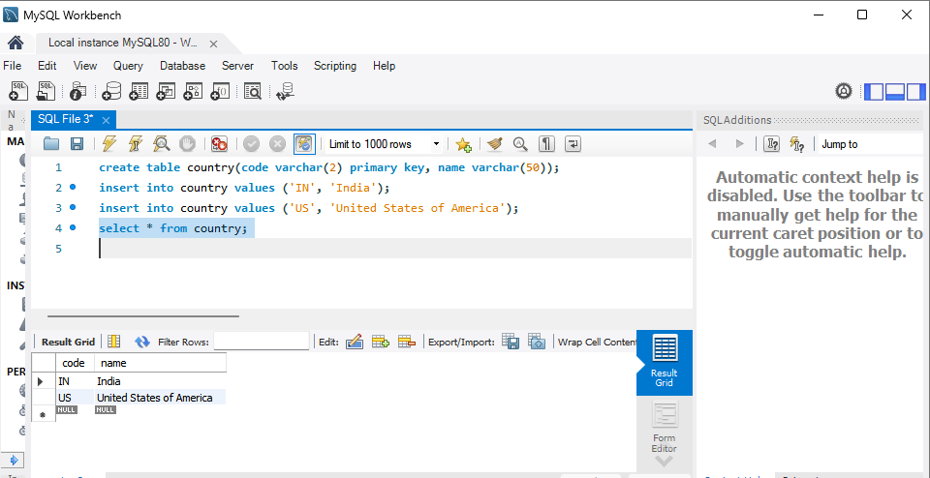

**3.Application Configuration (**application.properties**):**

* Configurations for MYSQL are added.
* Logging configurations are also added.

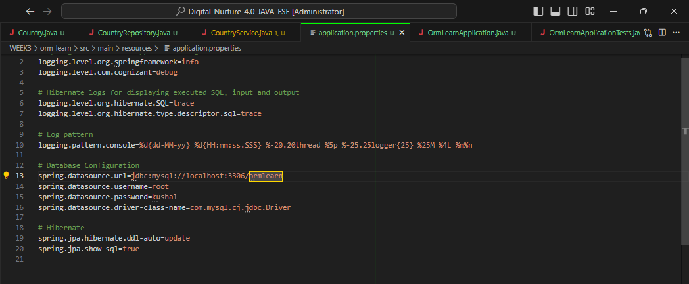

**4.Entity Class, Service Class and Repository Interface created:**

* **Country** class created with name and code as *@Id*. It is made and entity using *@Entity*
* *CountryService* created along with getAllCountries() method.Annotation @Transactional is

used to run in DBMS transaction.

Follow *package com.cognizant.ormlearn to access the model, repository and controllers.*

**5.Testing via OrmLearnApplication (Main Class): Output(Screen shot)**

